CLOVIS TRANSIT
GENERAL INFORMATION

What is Round Up Service?

Clovis Round Up is a service designed to meet the transportation needs of eligible persons with disabilities who cannot functionally use the Clovis Stageline city bus system.

The Americans with Disabilities Act (ADA) of 1990 requires public transportation agencies to prove paratransit service to eligible persons with disabilities that are comparable to the City bus service. Round Up is a shared ride, curb-to-curb service that provides transportation from any origin to any destination within the service area for any trip purpose. Round Up operates during the same days and hours as the Stageline bus system.

What is the website for the City of Clovis Transit Division?

www.cityofclovis.com/transit

How to contact Round Up, Stageline, or Clovis Transit?

For Round Up information including services and eligibility, to schedule or cancel a ride, or get information about Round Up:

(559) 324-2760

For Stageline information including bus schedules and route information:
(559) 324-2770

The Clovis Transit Office is located at:

City of Clovis Operations & Maintenance Yard
155 N. Sunnyside Avenue
Clovis, CA 93611

For inquiries, complaints, or compliments, or to file an appeal:

Clovis Transit Supervisor
155 N. Sunnyside Avenue
Clovis, CA 93611
(559) 324-2769

ROUND UP ELIGIBILITY

Who is eligible for Round Up Service?

Round Up provides service to ADA eligible individuals, a personal care attendant, one companion, and up to 4 children under the age of 6 years.

ADA: Anyone meeting the eligibility criteria for ADA paratransit services is eligible for Round Up service.

ADA Certified Eligible Visitors: ADA paratransit certified eligible visitors to the area (outside the Round Up service area) may receive Round Up service up to 21 days.

Disclaimer: Round Up reserves the right to refuse service to anyone that disrupts the operation of the vehicle or threatens the driver and/or other passengers.

How does someone become ADA eligible for Round Up?

Interested persons must complete an application to begin the 21 day evaluation process for eligibility. Applications are available by mail, as a download from our website, or can be picked up at one of the following locations:

Clovis Transit Offices
155 N. Sunnyside Avenue
Clovis, CA 93611

Clovis Senior Center
850 4th Street
Clovis, CA 93612

Once the completed application is received by the Clovis Transit offices, a determination of eligibility will be made using the standards outlined in the ADA within 21 days.

Applicants will receive an eligibility determination letter from Clovis Transit. Applicants with a qualifying temporary disability would receive certification for the length of time needed.

What can be done if eligibility has been denied?

An individual who has been denied American with Disabilities Act (ADA) paratransit eligibility may obtain a review of the denial determination by filing an appeal within 60 days from the denial of the application.

The Denied Eligibility Appeal Process includes an opportunity to present information and arguments in writing or in person to an individual who was not involved in the initial decision to deny eligibility.

To file an appeal, you may send written information to the address listed below, or you may request a personal interview by contacting the Transit Supervisor.

Transit Supervisor
City of Clovis Transit
155 N. Sunnyside Avenue
Clovis, CA 93611
(559) 324-2769

Written notification would be provided regarding the outcome of the appeal.

If the determination to deny eligibility were overturned, a letter of eligibility would be sent to the applicant.

If the determination to deny eligibility were upheld, a letter stating the reasons for the ruling would be sent to the applicant.

At the discretion of the applicant, a second appeal may be presented to an outside ADA agency. This outside agency would have the final say regarding ADA paratransit eligibility appeals. Written notification of the determination would be provided to the applicant within 30 days from the completion of the appeal process.

What is the service area of Round Up?

To use Round Up services, passengers must reside or begin their trip in the area roughly bordered by Shepherd, Willow, Ashlan, and DeWolf (see map for details). Transportation is provided within this area and into portions of Fresno. Service into Fresno is bordered by Shepherd, West, Kings Canyon, and Willow.

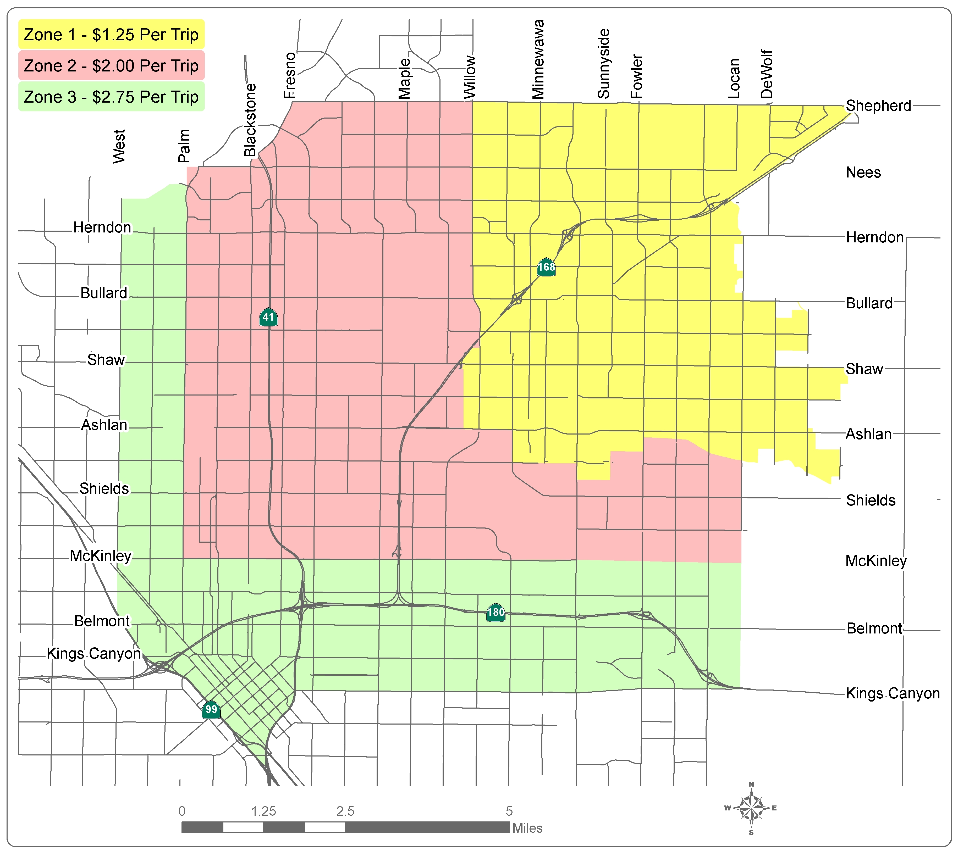

What are Round Up’s hours of operation?

Service Hours:
Monday – Friday 6:30am – 7:15pm
Saturday – Sunday (Clovis Trips Only) 7:30am – 3:00pm

Clovis Transit Round Up and Stageline Phone Hours:
Monday – Friday 7:00am – 7:15pm
Saturday – Sunday 7:30am – 3:00pm

Reservation Hours:
Monday – Friday 7:00am – 5:00pm
Saturday – Sunday 7:30am – 3:00pm

What holidays are observed?

Round Up will not provide service on the following holidays or on the days they are observed:

New Year’s Day Independence Day
Presidents’ Day Labor Day
Easter Sunday Thanksgiving Day
Memorial Day Christmas Day

Round Up will provide trips in Clovis only on the following holidays:

Martin Luther King, Jr. Day
Veterans’ Day
Friday after Thanksgiving

How much does it cost to ride Round Up?

Fares:
ADA Individual per ride fare
Clovis destinations ………………………………..…….. $1.25
Fresno (Willow to Palm, Shepherd to McKinley) …….. $2.00
Fresno (Palm to West, McKinley to Kings Canyon)...... $2.75

ADA Eligible Individual’s Personal Care Attendant ………….. Free
ADA Eligible Individual’s Children under age 6 (limit 4) …….. Free

Round Up passes are available in the following denominations:

One-way fares for Round Up within Clovis are $1.25. Travel to Fresno ranges from $2.00 to $2.75. New passes for Round Up are now available. Passengers purchase a $25 pass ($27.50 value) to use with the new electronic fare boxes. Clovis Transit has discontinued the sale of the punch passes (pink, blue, and purple). Any of these passes still in circulation will be accepted.

Passes are available for purchase by mail and at the following locations:

Clovis Senior Center Clovis City Hall
850 4th Street 1033 5th Street
Clovis, CA 93612 Clovis, CA 93612

How can I request a ride on Round Up?

The method for requesting a trip on Round Up begins with a reservation. Reservations for eligible passengers and eligible visitors may be made up to 14 days in advance but no later than one day prior to the requested trip.

Round Up reservation phone hours are:
Monday – Friday 7:00am – 5:00pm
Saturday – Sunday 7:30am – 3:00pm

The telephone number to make a reservation is (559) 324-2760.

What information will be needed to make a reservation?
- Passenger’s name
- Passenger’s pick-up address including apartment number, building number, specific instructions, or special directions.
- What time the passenger needs to arrive at their desired destination.
- If a mobility device or Personal Care Attendant will be traveling with the passenger.
- Number of companions or children traveling with the eligible passenger.
- Passenger drop-off address including suite number, building number, location within a building complex, and name of the location

To return back to the original pick-up point, the passenger will call the Round Up office and a bus will be sent to the location.

When will the bus arrive for a pick-up and how long will it take?

Trips in Clovis will be scheduled on the half hour and passengers are required to be ready 45 minutes prior to the desired arrival time at their destination. For example, a Clovis trip with the desired arrival time of 8:30am will require the passenger to be ready at 7:45am.

Trips in Fresno are scheduled at the top of the hour and passengers are required to be ready 1 hour prior to the desired arrival time at their destination. For example, a Fresno trip with the desired arrival time of 1:00pm will require the passenger to be ready at 12:00pm.

The Round Up bus will arrive to the pick-up location within a 15-minute window of time of the ‘be ready’ time.

Once the Round Up bus arrives at the pick-up location, the driver is required to wait 5 minutes and then must leave for the next scheduled pick up. This applies to outgoing and return rides.

How do I cancel my scheduled ride?

To cancel a scheduled trip, a passenger should call the Round Up office at (559) 324-2760 as soon as possible. To avoid acquiring a NO SHOW, the trip must be cancelled at least one hour before the scheduled pick-up time.

What is a no show?

A no show occurs when a scheduled pick up has not been previously canceled at least one hour prior to the scheduled pick-up time and/or the Round Up bus arrives for a passenger who does not take the ride.

The driver will go to the door and attempt to make contact with the passenger. If no contact is made, the driver will leave a yellow missed ride notification hanger on the door.

A no show also occurs when a passenger calls for a return ride, the bus arrives at the return location but the passenger is not present or anywhere the driver can quickly locate him/her.

What happens when a passenger has a no show?

No shows make it difficult to provide efficient service and may cause delays and inconveniences for other riders.

Round Up’s policy for no shows:

If a passenger accumulates two no shows with in one calendar month, the passenger will receive a warning letter explaining the no show policy.

In the case that a passenger incurs another month with two no shows within one year of receiving a warning letter, that passenger will be suspended from using Round Up service for one month.

The passenger can appeal the suspension of service by submitting a written appeal within 30 days to the Clovis Transit Supervisor. If the passenger is unable to file a written appeal, a verbal appeal may be arranged. Written notification regarding the decision will be mailed to passenger.

What are important points to know?

- Exact fare is required. Drivers do not carry change.
- Drivers will assist with up to 5 packages with a combined weight of no more than 25 pounds total.
- Drivers are required to secure mobility devices to vehicle. Passengers using mobility devices will be asked to transfer to a regular seat, if possible.
- Seat belt use is required at all times.
- Children under eight years of age or weighing less than 80 pounds must ride in a car safety seat that is provided by and secured by the child’s parent or legal guardian.
- Round Up is a shared-ride service which means that several passengers may be on the bus at the same time.
- For safety reasons, drivers are required to stay within sight of the vehicle at all times and may not travel further than 100 feet to provide assistance.

Can service animals ride on Round Up?

Service animals are animals that are individually trained for people with disabilities – such as guiding people who are sight impaired, alerting people who are hard of hearing, pulling wheelchairs, alerting and protecting a person who is having a seizure, or performing other special tasks. A transit provider may ask if an animal is a service animal or ask what tasks the animal has been trained to perform, but cannot require special ID cards for the animal or ask about the person’s disability. A service animal may not be excluded unless the animal is out of control and the animal’s owner does not take effective action to control it, or the animal poses a direct threat to the health or safety of others. Section 37,167(d)DOT ADA

